- Which type of graph is useful for comparing the distribution of a numerical variable across different categories?
- Scatter plot
- Boxplot
- Bar chart
- Histogram

- The table shows the distribution of students’ performance in physics. Calculate the average grade.
Grade 1 2 3 4 5
Number of students 6 11 9 3 1

- 2.2
- 2.3
- 2.4
- None of these
- 2.1

- Determine the range for the following survey data: 4, 3, 4, 3, 3, 2, 4, 3, 4, 2
- 2
- 3.2
- None of these
- 0.62
- 4
Range=max−min=4−2=2

- Which of the following explains the phenomenon that while in 10 flips of a fair coin it may be very surprising to get 8 Heads, it would be very surprising to get 8,000 10,000 flips of the coin.
- Bayes theorem
- General addition rule
- Law of large numbers
- Law of averages

- Suppose you observe a data point x = 12 and it is known that this data point came from a normal distribution with mean 5 and standard deviations 2. Which of the following statements is true regarding the observation of x = 12?
- The observation would be considered unusual because it is farther it is farther three standard deviations from the mean
- The observation would not be considered unusual, because we know exactly which normal distribution it comes from
- The observation would not be considered unusual, because it comes from a normal distribution
- The observation would be considered unusual because x = 12 is over twice as large as the mean of the distribution
- The observation would not be considered unusual because it is only about three standard deviations from the main
Answer: Z = (12−5)/2 ​=3.5
A Z-score of 3.5 means that x=12 is 3.5 standard deviations above the mean.
Given that x=12 is 3.5 standard deviations from the mean, this observation would indeed be considered unusual.

- It was estimated in a pilot survey carried out on 1600 subjects that 62% of the people in a population of interest were in favor of installing a wind farm helped reduce their own home energy cost. The corresponding 99% confidence interval for this proportion is :
- (60.50%, 63.5%)
- (59.6%, 64.4%)
- (58.9%, 65.1%)
- (60.8%, 63.2%)

90% | 1.645

95% | 1.96

98% | 2.33

99% | 2.576

- We are testing the following hypotheses: H0: µ = 3 HA: µ > 3. The sample size is 18. The test statistic is calculated as t = 0.5. What is the p-value?
- greater than 0.1
- between 0.005 and 0.1
- between 0.01 and 0.025
- less than 0.01
- less than 0.005

- A study was set up to examine the association between brain volume and schizophrenia. Investigators measured the grey matter volume (cm3) in 40 healthy and 40 schizophrenic subjects. The results on an analysis are summarized as follows:
- A mean grey matter volume of 715.7040cm3 was measured for the sample of healthy subjects
- A mean grey matter volume of 684.0680cm3 was measured for the sample of schizophrenic subjects
- Testing for equality of variances yielded a p-value < 0.001;
- Applying a two-sample t-test for equality of means under the hypothesis of equal population variances yielded a p-value of 0.0022
- Applying two-sample t-test for equality of means under the hypothesis of unequal population variances yielded a p-value of 0.024
Based on this analysis, which of the following statements about the difference between the two means is correct?
- The brain volume of schizophrenic subjects it larger than that of healthy subjects in this population
- The null hypothesis of equal brain volumes between health and schizophrenic subjects should be accepted
- The alternative hypothesis of different brain volumes between health and schizophrenic subjects should be rejected
- The null hypothesis of equal brain volumes between health and schizophrenic subjects should be rejected

- In business analytics, a one-way analysis of variance (ANOVA) is used to :
- Compare the means of two or more independent groups
- Determine the strength of association between two categorical variables
- Predict the future values of a time series data
- Analyse the correlation between two continuous variables

- In a one-way ANOVA, if eta squared = 0.75, what does this value indicate?
- 75% of the variation in the independent variable is explained by the model
- 75% of the variation in the dependent variable is explained by the model
- 75% of the variation in the residuals is explained by the model
- The ANOVA model is not a good fit for the data

- What does the within-groups variation represent in a one-way ANOVA?
- The variation in the dependent variable attributed to chance or random fluctuations,
- The variation in the independent variable explained by the dependent variable
- The variation in the dependent variable explained by the independent variable
- The variation in the dependent variable due to the interaction between multiple independent variables

- When comparing the results of a one-way ANOVA and a t-test for two independent groups, what do you expect to observe if the sample sizes are equal?
- There is no relationship between the F statistic from the ANOVA and the t statistic from the t-test
- The F statistic from the ANOVA will be equal to the t statistic from the t-test
- The F statistic from the ANOVA will be smaller than the t statistic from the t-test
- The p-value from the ANOVA will be equal to they p-value from the t-test

- If the between-groups variation, B, in the one-way ANOVA decomposition is much larger than the within-groups variation, W, what can you conclude about the effect of the factor on the dependent variables?
- The factor has a significant effect on the dependent variables
- The factor has no effect on the dependent variables
- The factor and the dependent variables are negatively correlated
- The factor is not related to the dependent variables

- Which of the following is NOT a condition required for comparing means across multiple groups using ANOVA?
- The data within each group should be nearly normal
- The observations should be independent within and across groups
- The means of each group should be roughly equal
- The variability across the groups should be about equal

- When doing an ANOVA, you observe large differences in means between groups. Within the ANOVA framework this would most likely be interpreted as:
- Evidence strongly favoring the null hypothesis
- Evidence revealing which group mean is different from the others
- None
- Evidence strongly favoring the alternative hypothesis

eta-squated represent in the context of one-way ANOVA?
The proportion of variation in the dependent variable explained by the model
in a one way ANOVA if p-value less than the chosen significance level, what does it indicate?
There is sufficient evidence to reject the null hypothesis

- An analyst is interested in studying the ages of customers. Which type of variable is age?
- Ordinal
- Categorical
- Continuous
- Discrete

- The primary difference between a histogram and a bar chart is thay ……..
- The histogram is used for qualitative data
- Histograms have an x- and y-axis
- The y-axis represents frequencies on a histogram
- There in no gap between the bars on a histogram

- What is the first quartile in a dataset?
- The mean of the lower half of the data
- The mean of the entire dataset
- The median of the entire dataset
- The median of the lower half of the data

- The mean and standard deviation of a dataset are 50 and 10, respectively. If each data point is multiplied by 3, what will be the new mean and standard deviation?
- Mean = 150, standard deviation = 30
- Mean = 50, standard deviation = 10
- Mean = 50, standard deviation = 30
- Mean = 150, standard deviation = 10
Answer:
• The new mean is 3×50=1503 \times 50 = 1503×50=150.
• The new standard deviation is 3×10=303 \times 10 = 303×10=30.

- The range is generally not a good way to assess variability because ……
- All of these
- It is difficult to calculate
- Is does not measure variability
- It is too robust
- It is easily influenced by outliers

- Heights of 10 year-olds, regardless of gender, closely follow a normal distribution with mean 55 inches and standard deviation 6 inches. Which of the following is TRUE?
- We would expect more 10 year-olds to be shorter than 55 inches than taller
- A 10 year-old who is 65 inches tall would be considered more unusual than a 10 year-old who is 45 inches tall
- A normal probability plot of heights of a random sample of 500 10 year-olds people should show a fairly straight line
- None of these

- When constructing a confidence interval for a population mean, increasing the confidence level will:
- Decrease the width of the interval
- Increase the width of the interval
- Have no effect on the width of the interval
- Make the interval undefined

- To get an estimate of consumer spending in the U.S. following the Thanksgiving holiday, 436 randomly sampled American adults were surveyed. Their daily spending for the six-day period following Thanksgiving averages $84.71. A 95% confidence interval based on this sample is ($80.31, $89.11). Which of the following are true?
- We are 95% confident that the average spending of the 436 American adults in this sample is between $80.31 and $89.11
- If we collected many random samples of the same size and calculated a confidence interval for daily spending for each sample, then we would expect 95% of the intervals to contain the true population parameter.
- We are 95% confident that the average spending of all American adults is between $80.31 and $89.11.
- I and II
- None
- II and III
- I, II, and III
- I and III

- Which of the following is a current interpretation of a p-value of 0.003?
- The data are inconsistent with the null hypothesis
- The data are consistent with the null hypothesis
- There is a 0.3% probability that the alternative hypothesis is true
- The power of the test is 0.3%.

- By randomly selecting 8 employees in one company, we found their average salary to be 20 750 CZK (sample standard deviation= 9 165 CZK ). Is the average wage in the enterprise significantly different from the national average in that year, which was CZK 24 429 in the business sector? Assume a significance level of alpha = 0.10. Select the current answer based on the correctly calculate p-value.
- No, because the p-value is close to 0 (<0.001).
- Yes, because the p-value 0.0294 is lower than the significance level
- No, because the p-value 0.294 is higher that the significance level
- Yes, because the p-value 0.701 is higher than the significance level

- The salaries of US business managers in the electronic industry were compared to assess whether managers who had previously graduated from an MBA had higher salaries, for otherwise comparable career profiles. A one-sided, two-sample t-test for equality of means was carried out on two samples of salaries (one from managers who did not hold an MBA, another from managers who held an MBA). The current alternative hypothesis for this test is:
- HA: mean salaries are equal for these two populations
- HA: mean salaries are different for these two populations
- HA: confidence intervals are different for these two populations
- HA: mean salaries are greater for managers holding an MBA than for managers not holding an MBA

- What is the possible range of values for eta-squared?
- 0 to 1
- - infinity to + infinity
- 1 to 100
- 0 to + infinity

- My friend, Tom, believes that his supermarket’s prices are lower than mine, and sets an altervative hypothesis test reflecting this. We construct a list of 10 indentical items and purchase them at our respective stores. Tom wants to know if these data support his hypothisis. Which of the following is the corrent description of Tom’s situation?
- Tom has a one-sided alternative hypotheses and should do an independent samples t-test
- Tom has a one-sided alternative hypothesis and should do a paired t-test
- Tom has a two-sided altervative hypothesis and should do a paired t-test
- Tom has a two-sided alternative hypothesis and should do an independent samples t-test

- A study was set up to examine the association between brain volume and schizophrenia. Investigators measured the grey matter volume (cm3) in 40 healthy and 40 schizophrenic subjects. A two-sided, two-sample t-test for equality of means yielded a p-value of 0.024, and the 95% confidence interval of the difference in population mean grey matter volumes was found to be (4.413cm3, 58.859cm3).
It is known that a difference of at least 70cm3 in grey matter volume is clinically important; the difference between the two means:
- May be clinically important
- Is clinically important
- Cannot be determined based on the information available
- is not clinically important

- When would you use a one-tailed hypothesis test instead of a two-tailed test?
- When you have a specific direction for the effect or difference
- When you want to test for a difference in two populations
- When you have equal variances in the populations
- When you have a large sample size

- A food safety inspector is called upon to investigate a restaurant with a few customer reports of poor sanitation practices. The food safety inspector uses a hypothesis testing framework to evaluate whether regulations are not being met. His hypothesis are:
- H0: The restaurant meets food safety and sanitation regulations
- HA: The restaurant does not meet food safety and sanitation regulations
- If he concludes that the restaurant meets food safety and sanitation regulations and the restaurant stays open when the restaurant is actually not safe, what type or effort does he make?
- Type III error
- Type I error
- Type II error

- The proportion of fake news circulated by one specific political candidate in a popular social media two months prior to a presidential election was estimated to be 82% of all posts emitted by this candidate. This estimate was obtained from a sample of 3600 posts from this applicant over the last two days. The corresponding 95% confidence interval for the true proportion of face news emitted by this candidate is:
- (80.3%, 83.6%)
- (81.5%, 82.5%)
- (80.0%, 84.0%)
- (80.7%, 83.3%)

- A doctor collects a large set of heart rate measurements that approximately follow a normal distribution. He only reports 3 statistics, the mean = 110 beats per minute, the minimum = 65 beats per minute, and the maximum = 155 beats per minute. Which of the following is most likely to be the standard deviation of the distribution?
- 35
- 15
- 5
- 90

- Calculate the 75th percentile of the Standard Normal variable:
- 0.395
- -0.395
- -0.675
- 0.675

- Determine the standard deviation of the following sample of survey data: 3,1,5,4,5
- 1.50
- None of these
- 1.67
- 2.80
- 2.24

- IQR answer
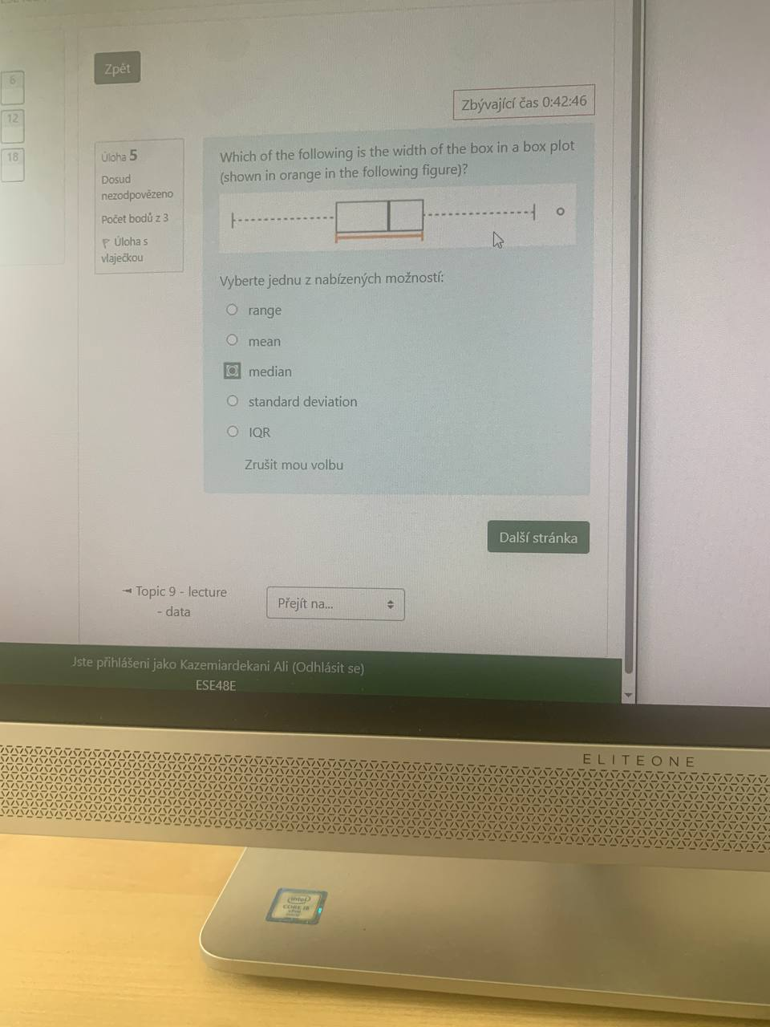

- Which of the following would be considered qualitative data?
- All of these
- 0.1, 2.5, 3.6, 0.8
- Blue, green, red, purple
- None of these
- 34, 8, 15, 12

- Which of the following classifications of variable types is FALSE?
- Population of each state in the US → continuous numerical
- Student height → continuous numerical
- Whether a student has previously taken a statistics course → categorical
- Customer satisfaction: very unsatisfied, unsatisfied, satisfied, very satisfied → ordinal categorical

- Which of the following would be considered qualitative data?
- Yes, no, yes, no
- None of these
- All of these
- 1st, 3rd, 2nd, 4th
- 5000, 7000, 9000, 3000

- The cumulative distribution of housing prices in a country where 25% of the houses cost below $350,000, 50% of the houses cost below $450,000, 75% of the houses cost below $1,000,000 and there are a meaningful number that cost than $6,000,000 is most likely.
- Symmetric
- Right skewed
- Uniform
- left skewed

- What will the final concentration of sulphuric acid if 8 kg of 18% acid and 2 kg of 96% acid were used in its preparation?
- 57 %
- 45.7 %
- 78.5 %
- 33.6 %
- None of these

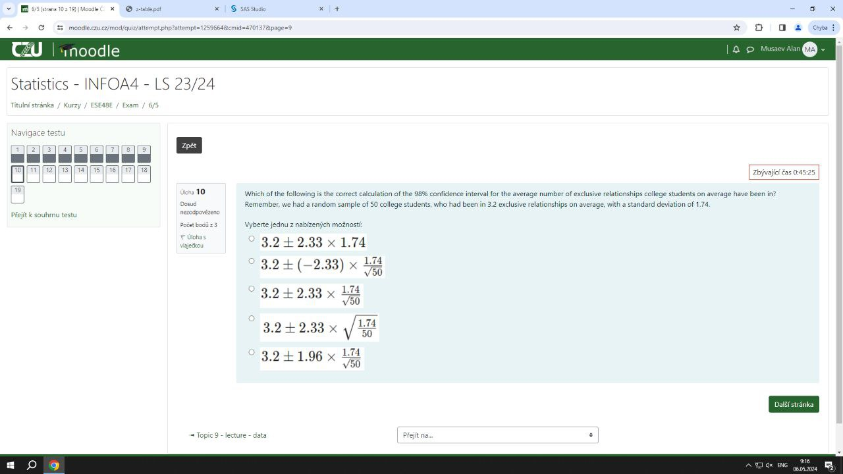

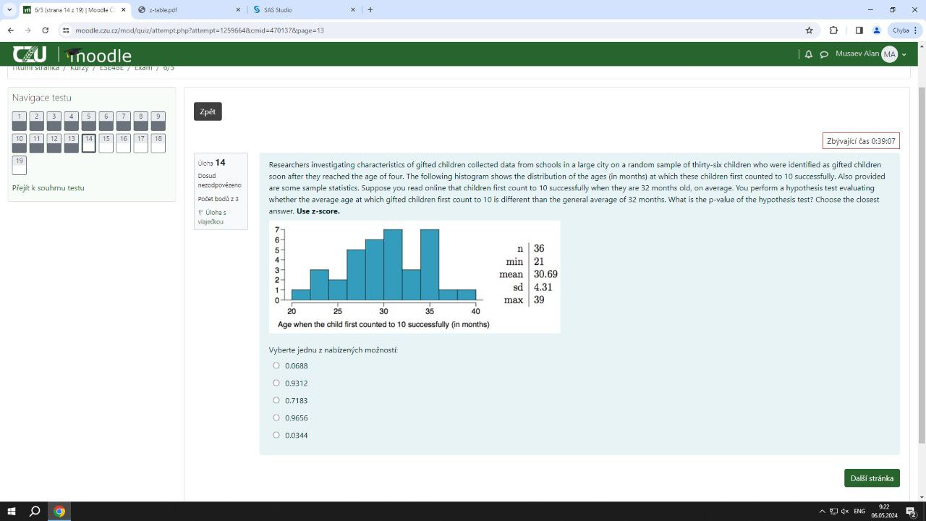

- What does the sample space represent in probability?
- The set of all possible outcomes of an experiment
- The set of favorable outcomes of an event
- The set of impossible outcomes
- The set of mutually exclusive events

- A coin is flipped three times. What is the probability of getting at least one head?
- 1/4
- 3/8
- 7/8
- 1/8

- Given the following SAS output, is there sufficient evidence to reject the hypothesis of equal means?

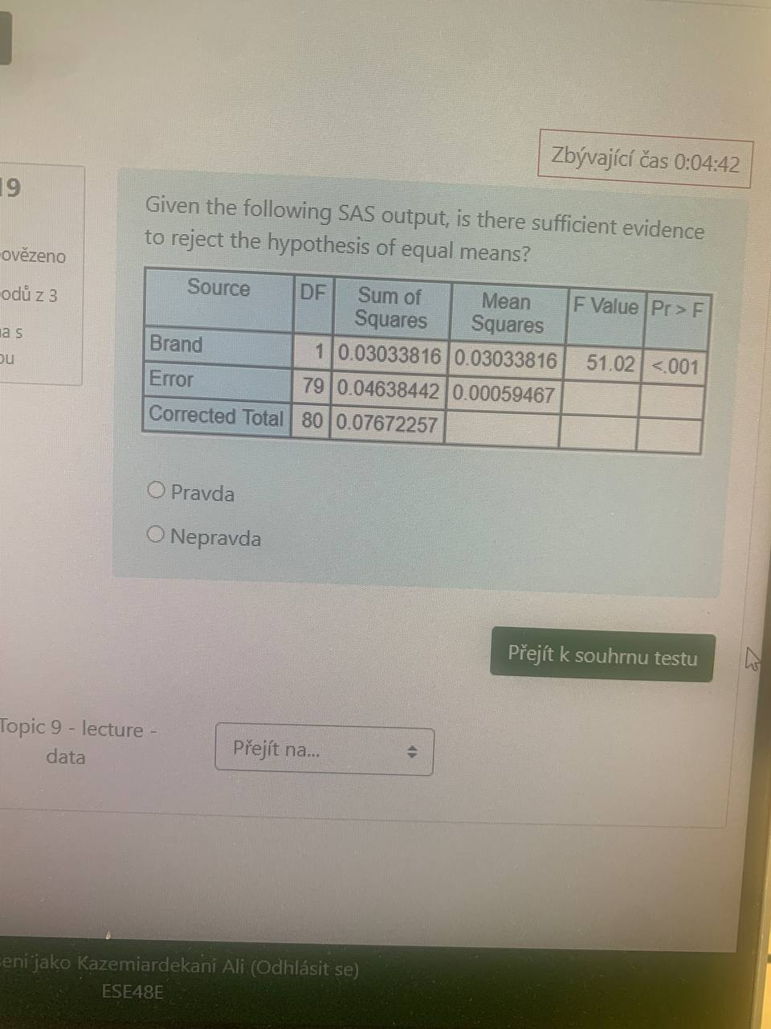

- We are testing the following hypothesis:
H0: µ =0.5
HA: µ ≠ 0.5
The sample size is 26. The test statistic is calculated as T = 2.485. What is the p-value?
- Higher than 0.05
- Lower than 0.01
- between 0.01 and 0.02
- between 0.02 and 0.05
- between 0.005 and 0.01

- A 95% confidence interval for SAT (Scholar Attendance Test) scores is (1157.90, 1223.35). What can you conclude from this information?

- The true average SAT score is significantly different from 1200.
- The true average SAT score is not significantly different from 1200.
- None of these. You cannot determine statistical significance from confidence intervals.
- The true average SAT score is less than 1200.

- Which of the following would be an example of continuous data?
- degrees Celsius
- O number of applicants
- favourite colour
- all of these
- none of these
- gender

- Which of the below data sets has the lowest standard deviation? You do not need to calculate the exact standard deviations to answer this question.
- 0,1,3,3,3,5,6
- 100, 100, 100, 100, 100, 100, 101
- 0,1,3,6,8,8,9
- 0,1,2,3,4,5.6

- Which of the following is FALSE?
- If two outcomes of a random process (both with probability greater than 0) are mutually exclusive, they are not necessarily complements.
- All of these
- If the probabilities of two mutually exclusive outcomes of a random process add up to 1, they are complements.
- When computing the probability that a card drawn randomly from a standard deck is either a Jack or a 4, you can use the addition rule.
- If two events (both with probability greater than 0) are mutually exclusive, they could be independent.

- Which of the following is FALSE? Hint: It might be useful to sketch the distributions.
- None of these.
- The Z score for the median of a left skewed distribution is most likely negative.
- Calculating percentiles based on the Z table is only appropriate for observations that come from (nearly) normal distributions.
- The Z score for the median of a symmetric distribution is approximately 0.
- Z scores are defined for observations from distributions of any shape and skew.

- You are about to take a multi-day tour through a national park which is famous for its wildlife. The tour guide tells you that on any given day there's a 61% chance that a visitor will see at least one "big game" animal, and a 39% chance they'll see no big game animals; when the tour guide says "big game", he refers to either a moose or a bear. The guide assures you that big game sightings on a single day are independent of any other day's sightings. Given the information from the tour guide, which of the following calculations CANNOT be performed using a binomial distribution?
- Calculate the probability that you see big game exactly 0 days of an 8-day trip.
- Calculate the probability that over a 5-day trip, you see big game on the first day and on every day after.
- Calculate the probability that you see big game on at least 8 days of a 10-day trip.
- Calculate the probability that you see at least 4 big game animals on the first day of a 5-day trip.

- A researcher found a 2006 - 2010 survey showing that the average age of women at first marriage is 23.44. Suppose a researcher believes that this value may have increased more recently, but as a good scientist he also wants to consider the possibility that the average age may have decreased. The researcher has set up his hypothesis test: which of the following states the appropriate alternative hypothesis HA correctly?
- HA: μ < 23.44 years old.
- HA: μ > 23.44 years old.
- HA: μ = 23.44 years old.
- HA: μ ≠ 23.44 years old.

- A bank manager is concerned that the percent of loans processed that contain errors has increased above the acceptable amount of 1%. A significance test is conducted to test his concern (HO: loan error rate<=0.01, Ha:loan error rate>0.01). Th manager concludes that the rate is indeed above 1%, when in reality it is not. What type of error did the manager make?
- Type III
- Type II
- Type I

- The p-value of the hypothesis test comparing the mean age at which gifted children first count to 10 successfully (30.69 months) against a general population mean of 32 months, we’ll use one-sample z-test
0.0688

- The between-groups variation (B) is much larger than the within-groups variation (W), this generally indicates that the factor being tested has a significant effect on the dependent variable.
The factor has a significant effect on the dependent variable

- Based on the description of a study examining brain volumes in healthy and schizophrenic subjects, where a two-sample t-test yielded a p-value of 0.001
The alternative hypothesis of different brain volumes between health and schizophrenic subjects should be accepted

- The mode is …….
- The most common value in a variable
- None of these
- The most robust measure of central tendency
- Appropriate for all scales of measurement
- All of these

- If you want to convert from a frequency to a relative frequency, you should ….
- Count how many times a value appears in your dataset
- Count the total number of values in the dataset
- Divide the frequency by the sample size
- Divide the sample size by the frequency

- The General Social Survey (GSS) is a sociological survey used to collect data on demographic characteristics and attitudes of residents of the United States. In 2010, the survey collected responses from 1.154 US residents. Based on the survey results, a 95% confidence interval for the average number of hours Americans have to relax or pursue activities that you enjoy after an average work day is 3.53 to 3.83 hours. Which of the following is FALSE?
- The sample mean is 3.68 hours.
- The standard error is approximately 0.075 hours.
- Increasing the confidence level would result in a more accurate but less precise confidence interval.
- The margin of error is 0.3 hours.

- Researchers investigating characteristics of gifted children collected data from schools in a large city on a random sample of thirty-six children who were identified as gifted children soon after they reached the age of four. The following histogram shows the distribution of the ages (in months) at which these children first counted to 10 successfully. Also provided are some sample statistics. Suppose you read online that children first count to 10 successfully when they are 32 months old, on average. You perform a hypothesis test evaluating whether the average age at which gifted children first count to 10 is different than the general average of 32 months. What is the p-value of the hypothesis test? Choose the closest answer. Use z-score.
- 0.0688 two tails
- 0.9312
- 0.7183
- 0.9656
- 0.0344 one tail?

- Nominal data would be considered dichotomous when …………
- The data are quantitative
- Labels have an order
- The data have only two possible values
- The data are ranked

- The repairer in garage repairs 6 machines. The probability that any machine breaks during the week is 0.15. How likely is it that less than 2 machines will break down during the week?
- 0.776
- 0.176
- 0.953
- 0.566
- 0.399

- Assume X has a Normal distribution with mean 10 and standard deviations 2. The probability that an observed value of X is between 5(or 8) and 11 is:
- 0.1498
- 0.4672
- 0.5328
- 0.8502

- The coefficient of variations= 0.018
standard deviation = 0.037
arithmetic mean = ? 2.06

- While it is often assumed that the probabilities of having a boy a girl are the same, the actual probability of having a boy is slightly higher at 0.51. Suppose a couple plans to have 3 children. What is the probability that exactly 2 of them will be boys?
0.38

- Suppose X is a Normally distributed random variable with a mean of 6 and a standard deviation of 0.05. The probability that x is less than 5.90. is:
- 0.4013
- 0.02275
- 0.0475
- 0.00621

- Which of the following is an example of appropriate for an independent samples test?
- All of these
- Employes from Branch A and employees from Branch B
- Sales in 2000 and sales in 2008 of the same group of companies
- Employees pre-and post-training

- F value ANONA answer is
1.87

